Sum of Even Series

Aim
To calculate the sum of even numbers up to a given limit using RAPTOR.

Apparatus Required
- Computer/Laptop
- RAPTOR Software
- Windows Operating System

Procedure
- Open RAPTOR.
- Input the limit.
- Initialize the sum as 0.
- Use a loop to add even numbers.
- Store the sum.
- Display the result.
- Execute the flowchart.
Flowchart
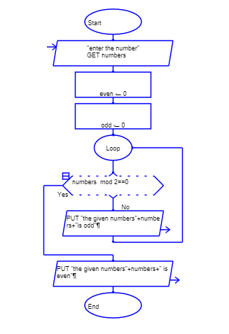

Input

Output


